**Phase 9: Reporting, Dashboards & Security Review**

**Goal :**

Deliver **powerful reporting & analytics** (Reports, Dashboards, Dynamic Dashboards) and implement **robust security controls** (Sharing Settings, Field-Level Security, Session Settings, IP Ranges, Audit Trail) to ensure data is both actionable and protected.

**1. Reports (Tabular, Summary, Matrix, Joined)**

* **Tabular Reports:**
  + Student List Report (Basic student details)
  + Attendance List Report (Daily/Monthly attendance)
* **Summary Reports:**
  + Class-wise Student Count
  + Attendance Percentage by Class
  + Grade Distribution Summary
* **Matrix Reports:**
  + Attendance Matrix (Rows = Classes, Columns = Months)
  + Grade Performance Matrix (Rows = Subjects, Columns = Terms)
* **Joined Reports:**
  + Student + Attendance + Grades combined view for holistic performance analysis
  + Course Enrollment + Completion Rate joined report

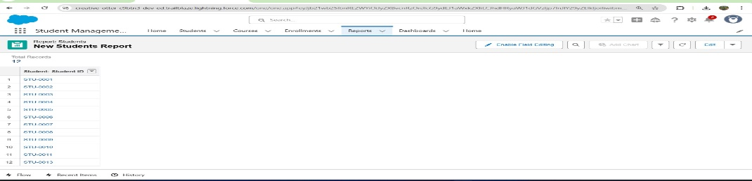

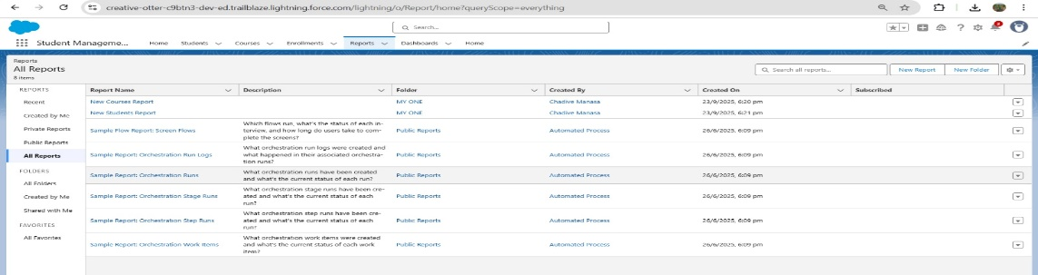

**2. Report Types**

* **Student Report Type:** Includes student personal details, contact info
* **Attendance Report Type:** Links Student → Attendance records
* **Grades Report Type:** Links Student → Grades with term/subject info
* **Courses Report Type:** Links Student → Courses enrolled, status, teacher details

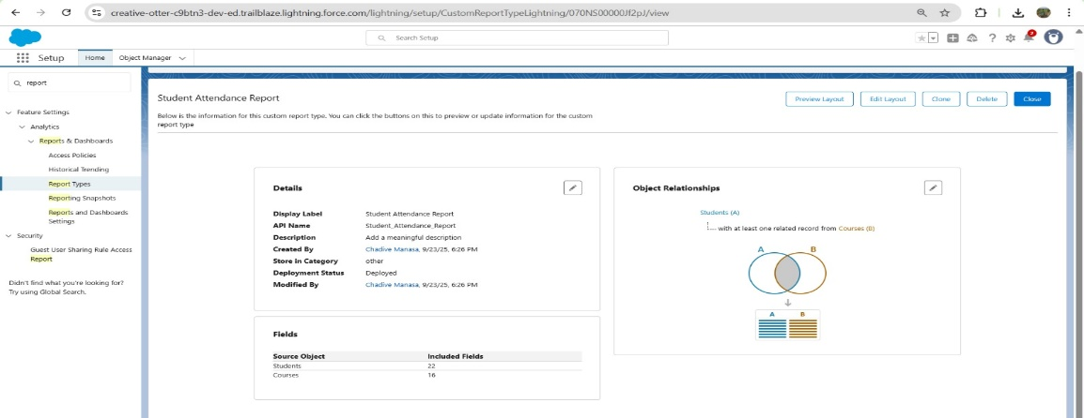

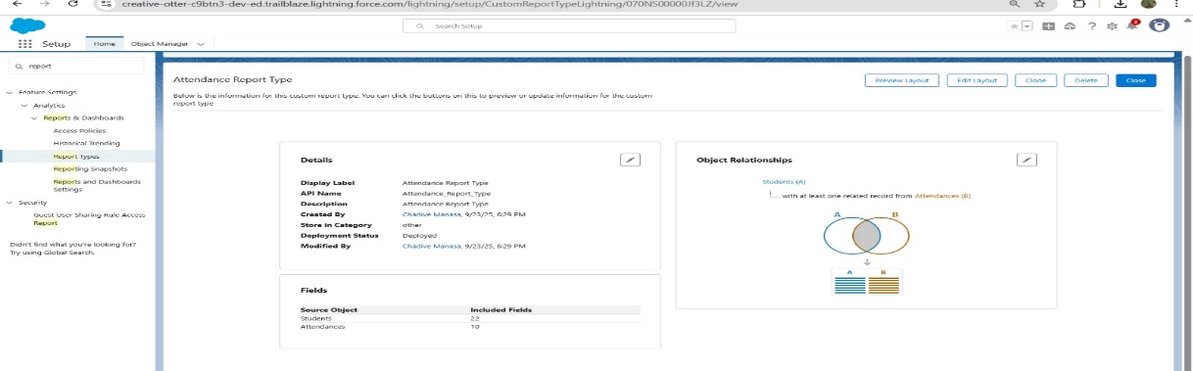

**3. Dashboards**

* **Student Overview Dashboard:** Total Students, New Admissions, Dropouts
* **Attendance Dashboard:** Present %, Absent %, Class-wise charts
* **Grades Dashboard:** Average Grades per Class, Top Performers, At-Risk Students
* **Course Dashboard:** Enrolment Trends, Most Popular Courses

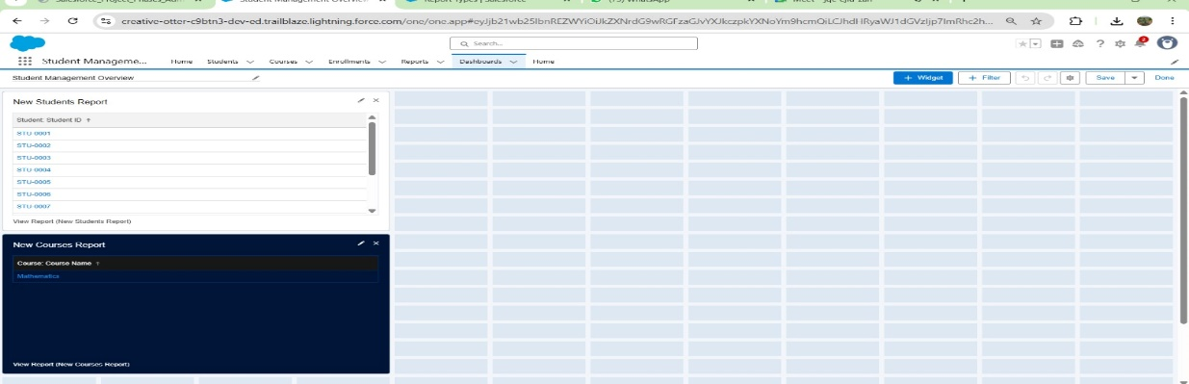

**4. Dynamic Dashboards**

* Configured dashboards to **run as logged-in user** so each Teacher sees only their class data, Principal sees their school data, and Admin sees all data.
* Applied **dashboard filters** (Class, Term, Subject) for real-time drill-down.

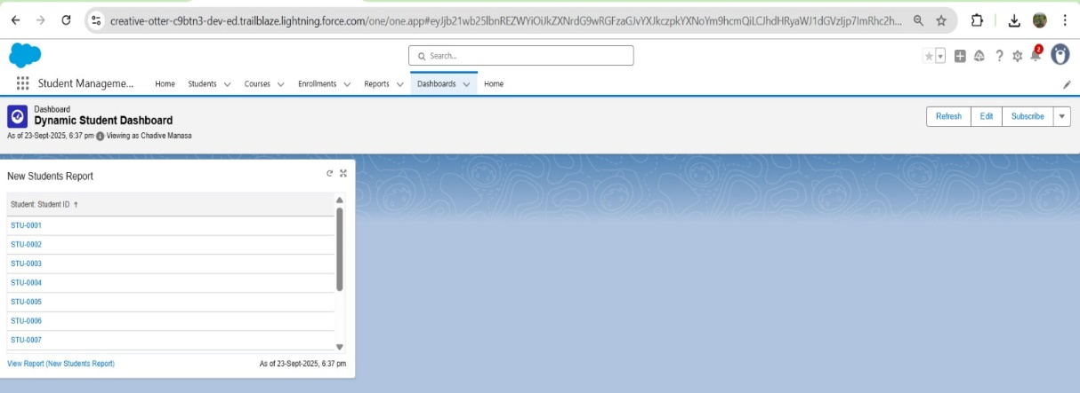

**5. Sharing Settings**

* **Organization-Wide Defaults (OWD):**
  + Students, Attendance, Grades = Private
  + Courses = Controlled by Parent

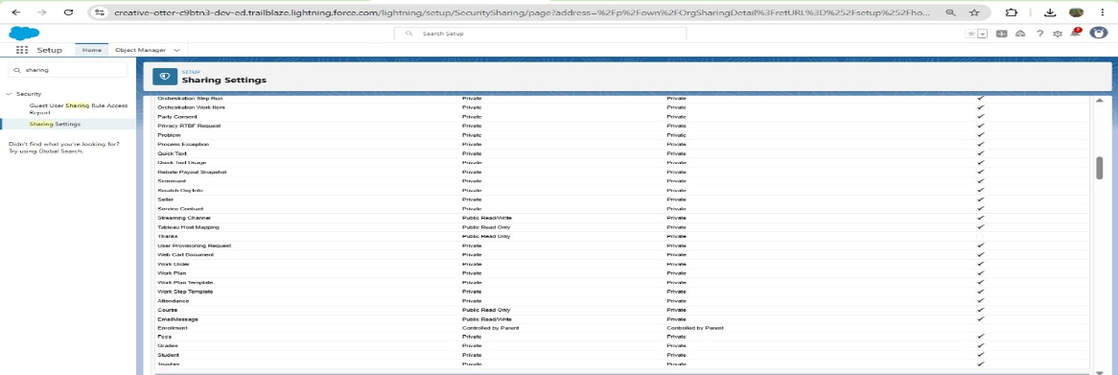

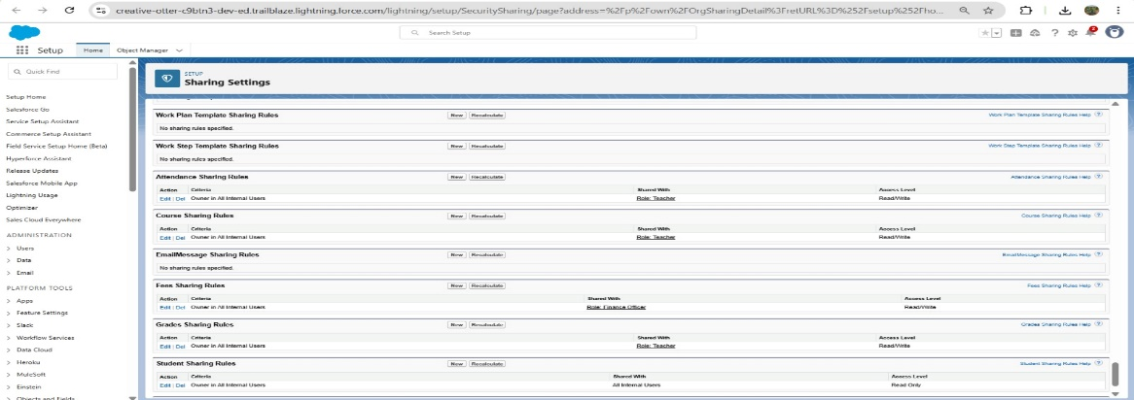

* **Role Hierarchy:**
  + Admin > Principal > Teacher > Student
* **Sharing Rules:**
  + Criteria-based rules to share records with Teacher Groups based on Class/Section
  + Owner-based sharing for Principals to access all data under their school

**6. Field-Level Security**

* **Sensitive Fields Restricted:**
  + SSN, Parent Contact Info → Visible to Admin & Principal only
  + Fee Details → Visible to Admin only
  + Grades → Read-Only for Teachers, Visible to Principal/Admin
* **Profiles Configured:** Admin, Principal, Teacher, Student with tailored field visibility

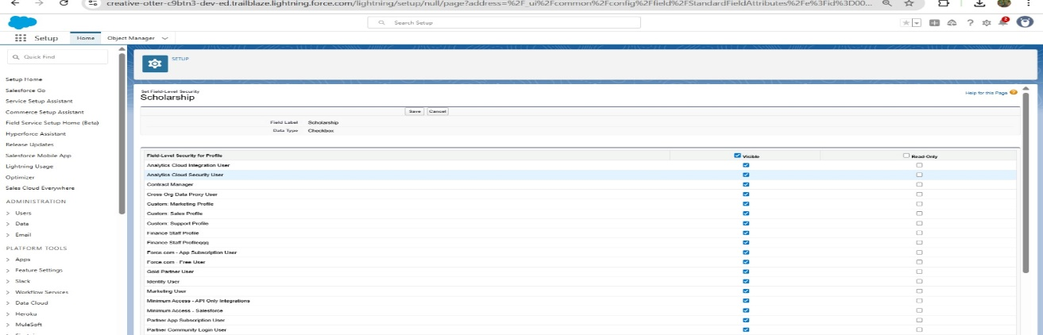

**7. Session Settings**

* **Session Timeout:** 30 minutes
* **Logout on Timeout:** Enabled
* **Lock Session to IP/Domain:** Enabled
* **Clickjack & CSRF Protection:** Enabled
* **HTTPS Required:** Enforced for secure communication

**8. Login IP Ranges**

* **Network Access (Org-Wide):** Added school’s LAN/Wi-Fi IP range
* **Profile-Specific Ranges:**
  + Teachers: Allowed only from school network
  + Admin: Allowed from office network + VPN
  + Students: Allowed from broader IP range (school + home if needed)

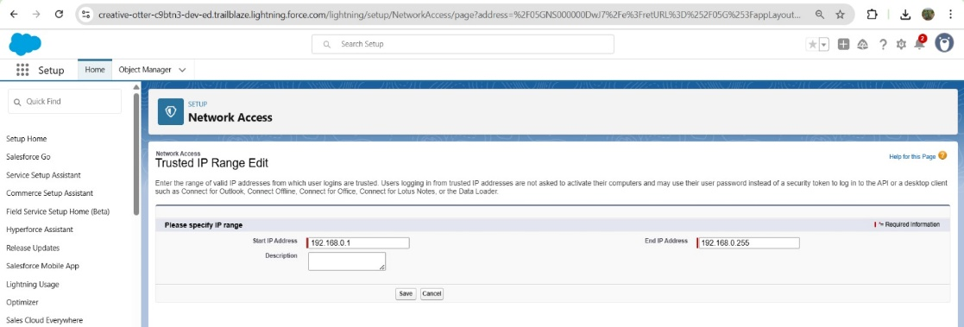

**9. Audit Trail**

* **Setup Audit Trail:** Enabled and reviewed for changes in roles, profiles, and settings
* **Field History Tracking:**
  + Tracked Fields: Student Status, Assigned Teacher, Grade Changes, Attendance Updates
* **Login History:** Monitored failed logins and suspicious attempts

